AK Successful Analysis
d.est
[1] 0.7189844
> model.temp

Title:
GARCH Modelling

Call:
garchFit(formula = ~arma(1, 0) + garch(3, 1), data = x, cond.dist = c("QMLE"),
include.mean = TRUE, trace = FALSE)

Mean and Variance Equation:
~arma(1, 0) + ~garch(3, 1)

Conditional Distribution:
QMLE

Coefficient(s):
mu ar1 omega alpha1 alpha2 alpha3
7.33837e-05 1.96178e-01 7.55261e-07 1.00000e-08 1.00000e-08 1.00000e+00
beta1
4.97848e-01

Error Analysis:
Estimate Std. Error t value Pr(>|t|)
mu 7.338e-05 1.616e-05 4.542 5.57e-06 ***
ar1 1.962e-01 4.319e-02 4.542 5.57e-06 ***
omega 7.553e-07 2.845e-07 2.655 0.00794 **
alpha1 1.000e-08 NA NA NA
alpha2 1.000e-08 NA NA NA
alpha3 1.000e+00 1.142e-01 8.755 < 2e-16 ***
beta1 4.978e-01 5.686e-02 8.755 < 2e-16 ***
---
Signif. codes: 0 ‘***’ 0.001 ‘**’ 0.01 ‘*’ 0.05 ‘.’ 0.1 ‘ ’ 1

Log Likelihood:
-1120.119 normalized: -3.944082

Description:
Wed Feb 25 20:13:42 2009 by user: tdr9

> Box.Ljung.test(sresi,12,11)

Box-Ljung test

data: data
X-squared = 15.9094, df = 11, p-value = 0.1445

> Box.Ljung.test(sresi^2,12,8)

Box-Ljung test

data: data
X-squared = 9.5669, df = 8, p-value = 0.2968

>
>
AL analysis
Linear interpolation
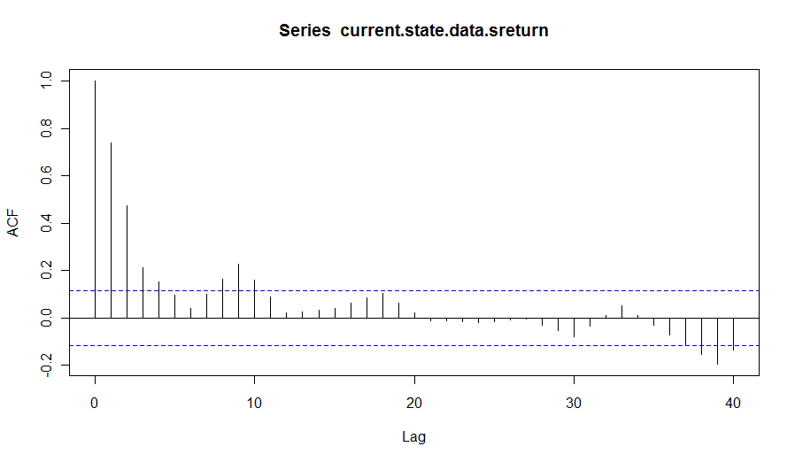
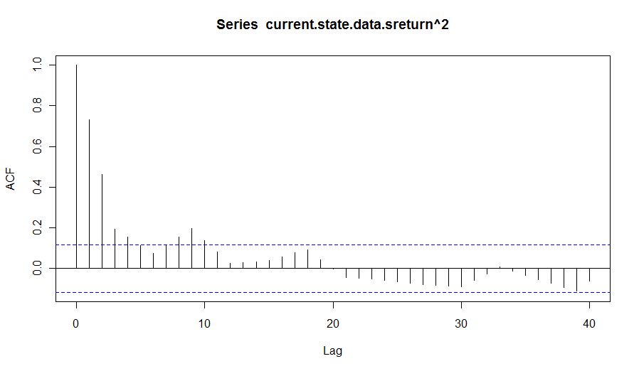
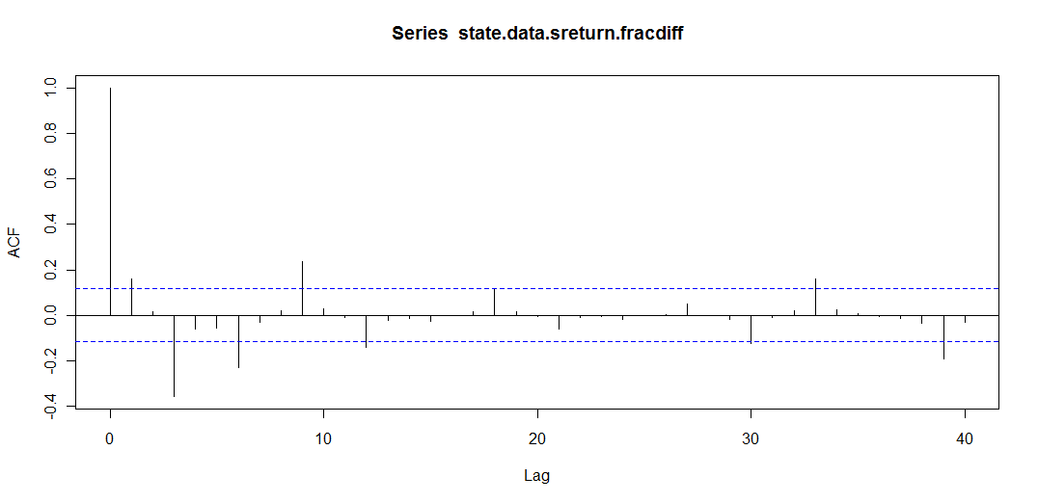
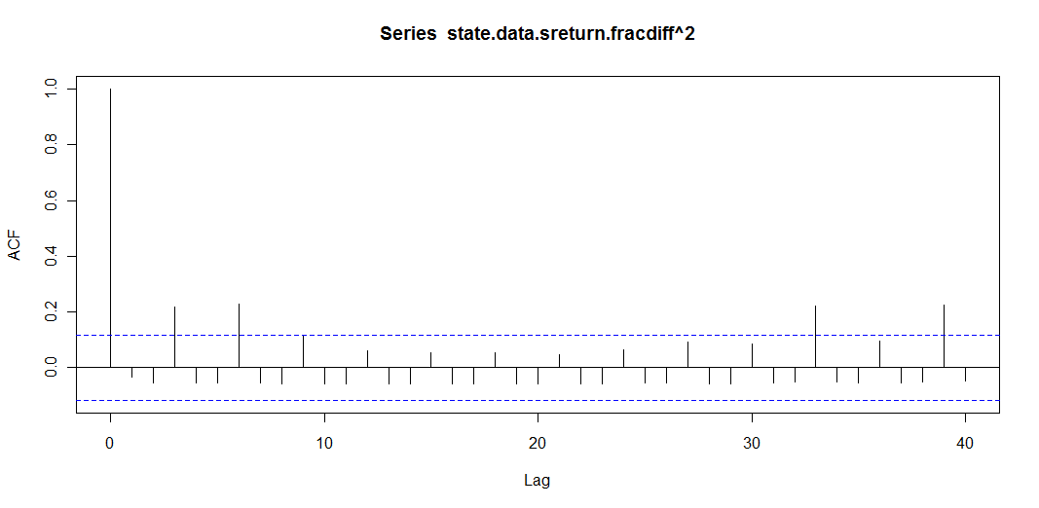
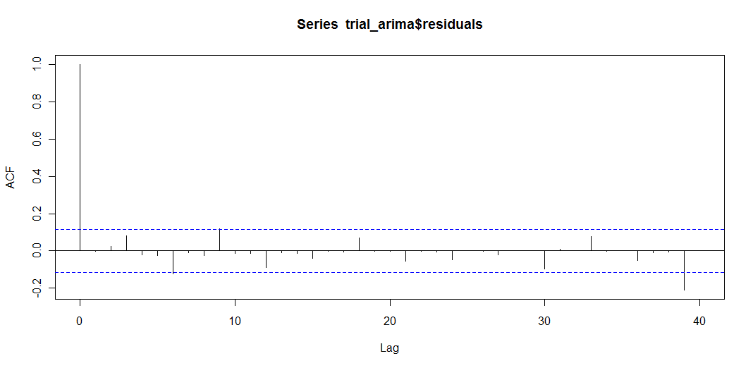

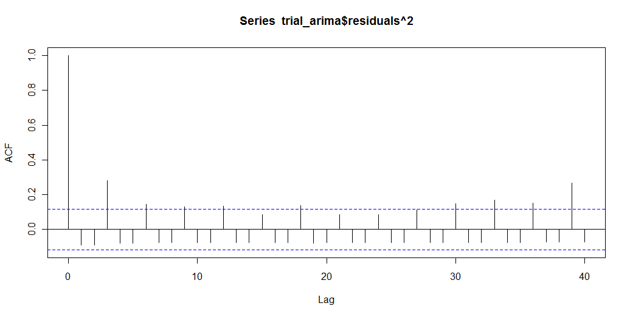

d.est (whittle)
> d.est
[1] 0.7714844
> trial_arima

Call:
arima(x = state.data.sreturn.fracdiff, order = c(0, 0, 3))

Coefficients:
ma1 ma2 ma3 intercept
0.1742 0.1452 -0.6813 0e+00
s.e. 0.0502 0.0527 0.0558 1e-04

sigma^2 estimated as 2.078e-06: log likelihood = 1453.66, aic = -2897.32
>
> Box.Ljung.test(trial_arima$residuals,12,9)

Box-Ljung test

data: data
X-squared = 16.5906, df = 9, p-value = 0.05553

> Box.Ljung.test(trial_arima$residuals^2,12,12)

Box-Ljung test

data: data
X-squared = 53.1904, df = 12, p-value = 3.81e-07

Final “Seasonal” Garch Model (using fractionally differenced series as input)

Coefficient(s):
mu ma1 ma2 ma3 omega alpha1
2.9927e-05 2.0939e-01 1.3187e-01 -3.5229e-01 1.0380e-06 1.0000e-08
alpha2 alpha3 beta1
1.0000e-08 1.0000e+00 1.0000e-08

Std. Errors:
robust

Error Analysis:
Estimate Std. Error t value Pr(>|t|)
mu 2.993e-05 9.118e-05 0.328 0.743
ma1 2.094e-01 2.990e-02 7.003 2.51e-12 ***
ma2 1.319e-01 6.779e-03 19.453 < 2e-16 ***
ma3 -3.523e-01 2.341e-01 -1.505 0.132
omega 1.038e-06 9.710e-07 1.069 0.285
alpha1 1.000e-08 2.064e-02 4.84e-07 1.000
alpha2 1.000e-08 2.594e-02 3.85e-07 1.000
alpha3 1.000e+00 9.442e-01 1.059 0.290
beta1 1.000e-08 3.990e-02 2.51e-07 1.000
---
Signif. codes: 0 ‘***’ 0.001 ‘**’ 0.01 ‘*’ 0.05 ‘.’ 0.1 ‘ ’ 1

Log Likelihood:
1475.816 normalized: 5.196534

Description:
Wed Feb 25 18:17:49 2009 by user: tim

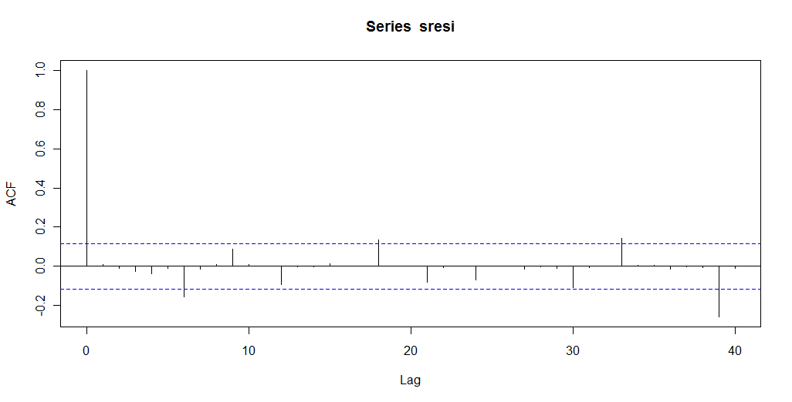
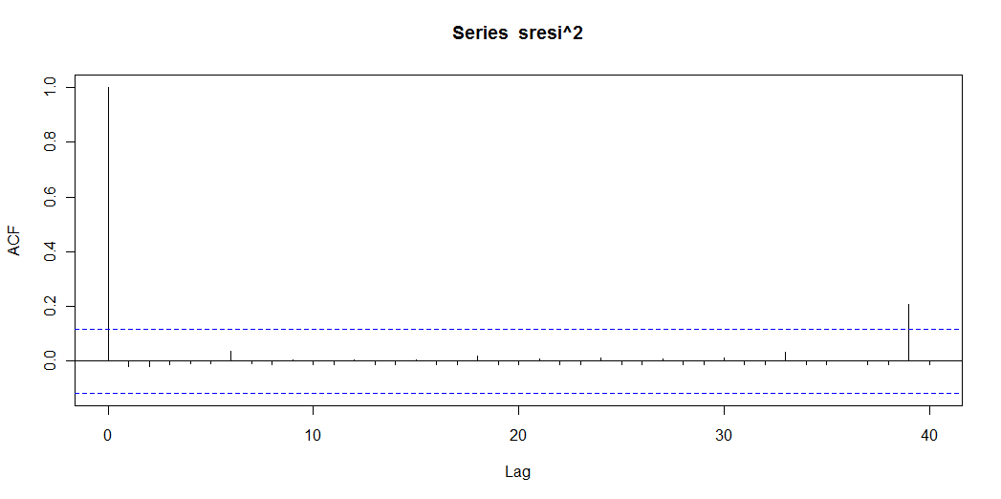

> acf(sresi^2,lag.max=40)
> Box.Ljung.test(sresi,12,8)

Box-Ljung test

data: data
X-squared = 12.7444, df = 8, p-value = 0.1210

> Box.Ljung.test(sresi^2,12,8)

Box-Ljung test

data: data
X-squared = 0.7954, df = 8, p-value = 0.9992
AR Successful
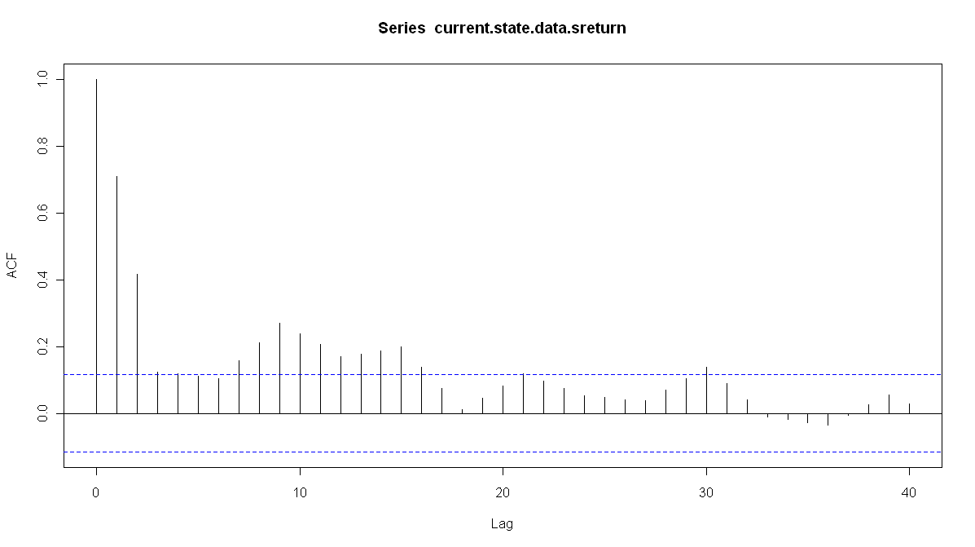
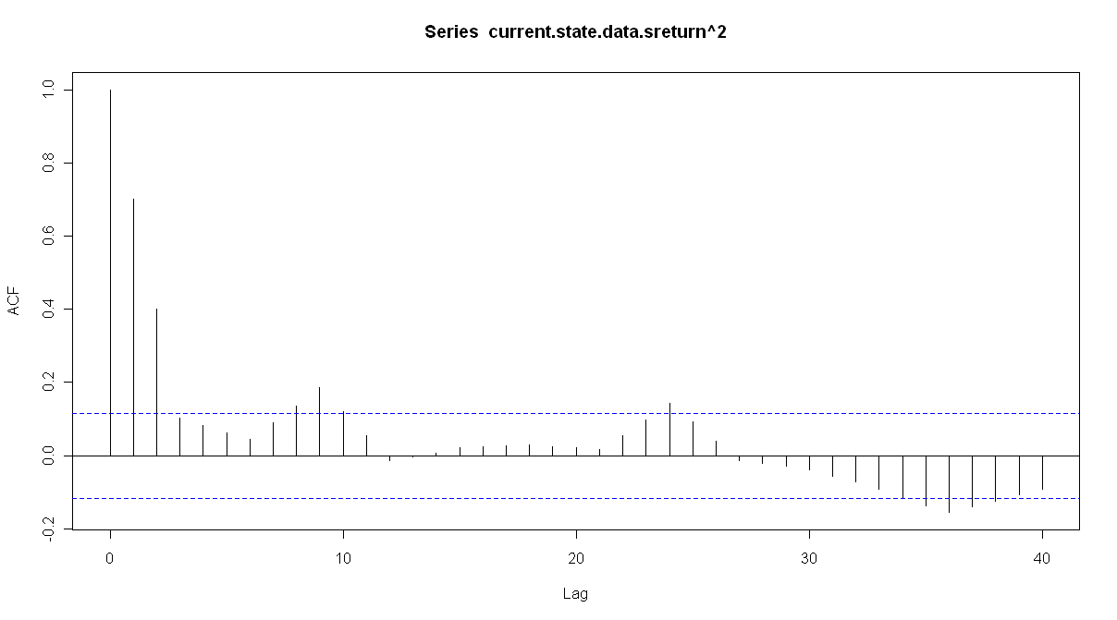
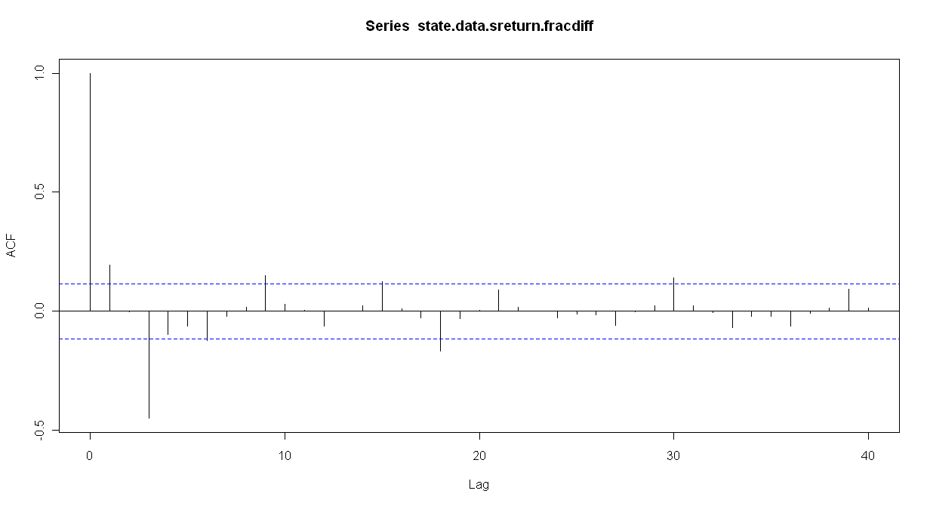
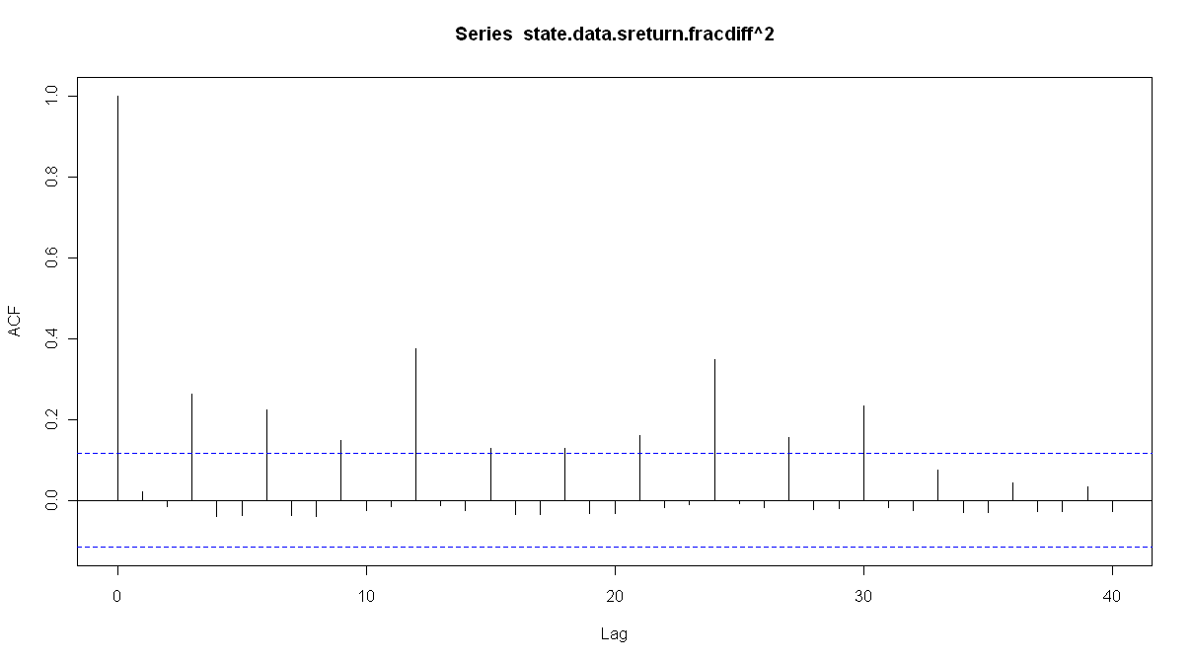
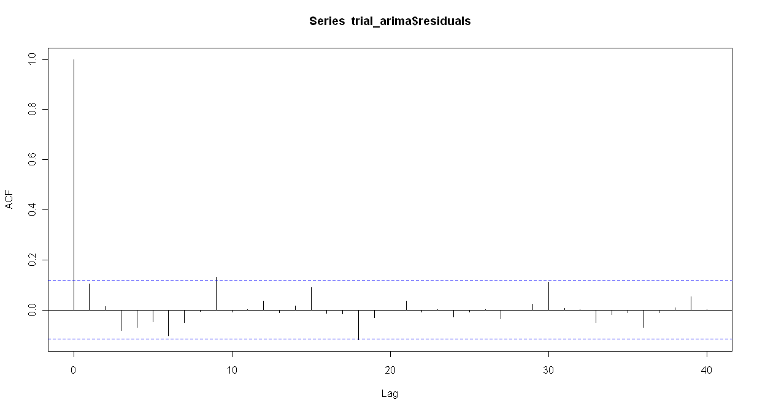
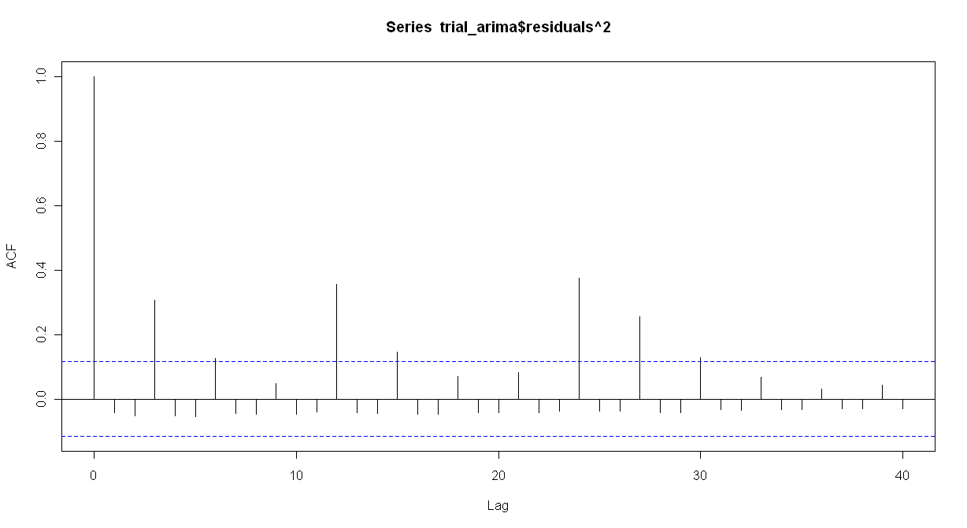
Call:
arima(x = state.data.sreturn.fracdiff, order = c(0, 0, 3))

Coefficients:
ma1 ma2 ma3 intercept
0.1940 0.1493 -0.6897 0e+00
s.e. 0.0499 0.0550 0.0502 1e-04

sigma^2 estimated as 3.149e-06: log likelihood = 1394.56, aic = -2779.12
> Box.Ljung.test(trial_arima$residuals,12,9)

Box-Ljung test

data: data
X-squared = 16.5329, df = 9, p-value = 0.05655

> Box.Ljung.test(trial_arima$residuals^2,12,12)

Box-Ljung test

data: data
X-squared = 75.2714, df = 12, p-value = 3.265e-11

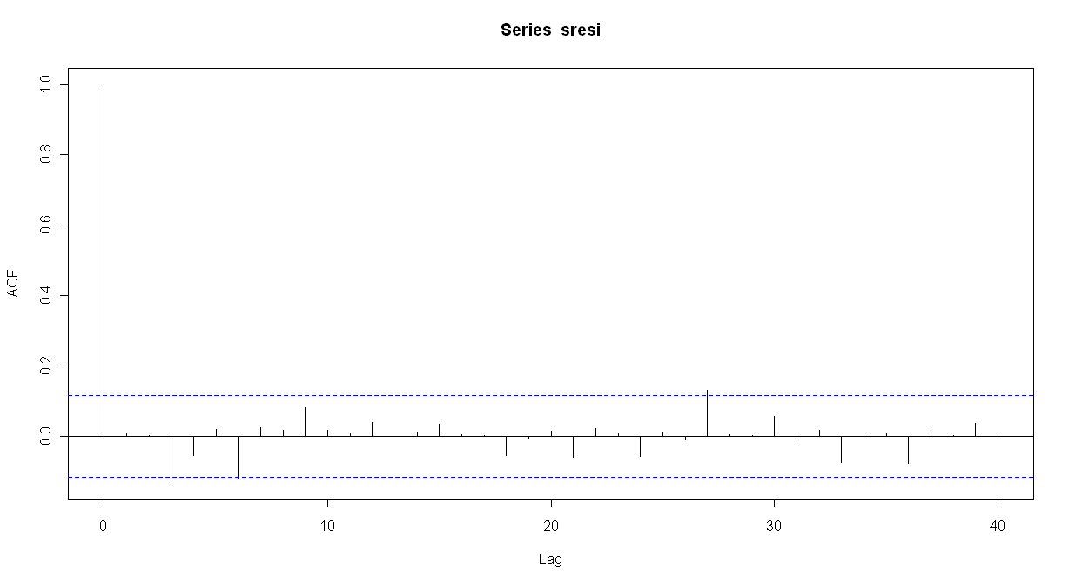
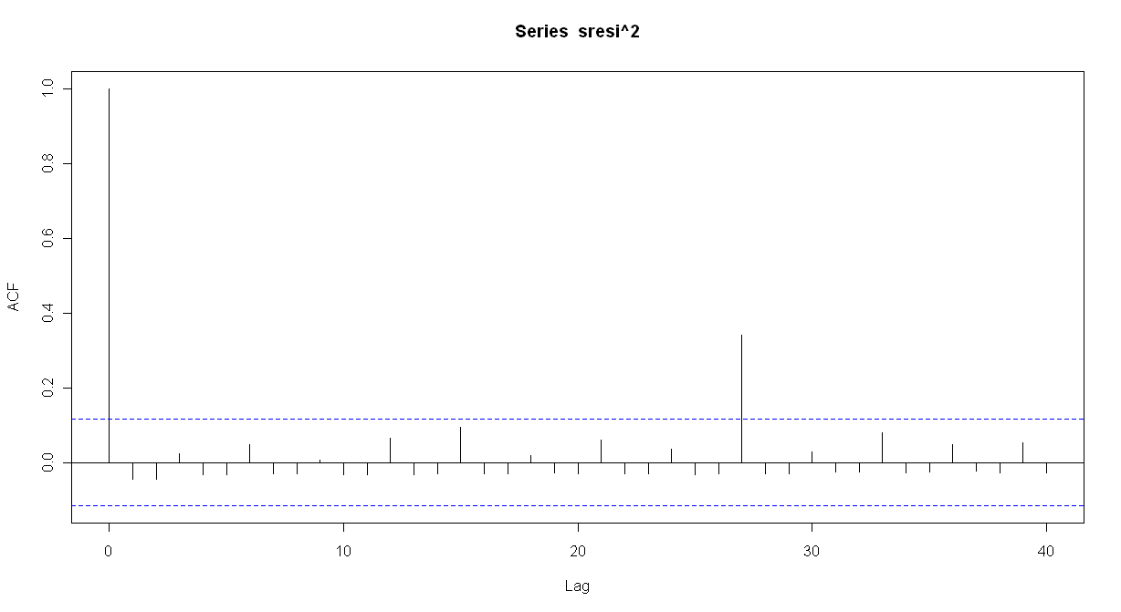
d.est
[1] 0.6991602
> model.temp

Title:
GARCH Modelling

Call:
garchFit(formula = ~arma(0, 3) + garch(3, 1), data = x, cond.dist = c("QMLE"),
include.mean = TRUE, trace = FALSE)

Mean and Variance Equation:
~arma(0, 3) + ~garch(3, 1)

Conditional Distribution:
QMLE

Coefficient(s):
mu ma1 ma2 ma3 omega
-9.98787e-05 2.96694e-01 1.90762e-01 -3.35984e-01 3.27321e-07
alpha1 alpha2 alpha3 beta1
1.00000e-08 1.00000e-08 1.00000e+00 1.00000e-08

Error Analysis:
Estimate Std. Error t value Pr(>|t|)
mu -9.988e-05 3.148e-05 -3.173 0.00151 **
ma1 2.967e-01 9.680e-03 30.652 < 2e-16 ***
ma2 1.908e-01 8.232e-03 23.172 < 2e-16 ***
ma3 -3.360e-01 8.437e-03 -39.822 < 2e-16 ***
omega 3.273e-07 7.063e-09 46.345 < 2e-16 ***
alpha1 1.000e-08 NA NA NA
alpha2 1.000e-08 NA NA NA
alpha3 1.000e+00 7.533e-02 13.274 < 2e-16 ***
beta1 1.000e-08 NA NA NA
---
Signif. codes: 0 ‘***’ 0.001 ‘**’ 0.01 ‘*’ 0.05 ‘.’ 0.1 ‘ ’ 1

Log Likelihood:
-1537.675 normalized: -5.41435

Description:
Wed Feb 25 19:49:36 2009 by user: tdr9

> Box.Ljung.test(sresi,12,9)

Box-Ljung test

data: data
X-squared = 12.9073, df = 9, p-value = 0.1668

> Box.Ljung.test(sresi^2,12,8)

Box-Ljung test

data: data
X-squared = 5.0059, df = 8, p-value = 0.757

